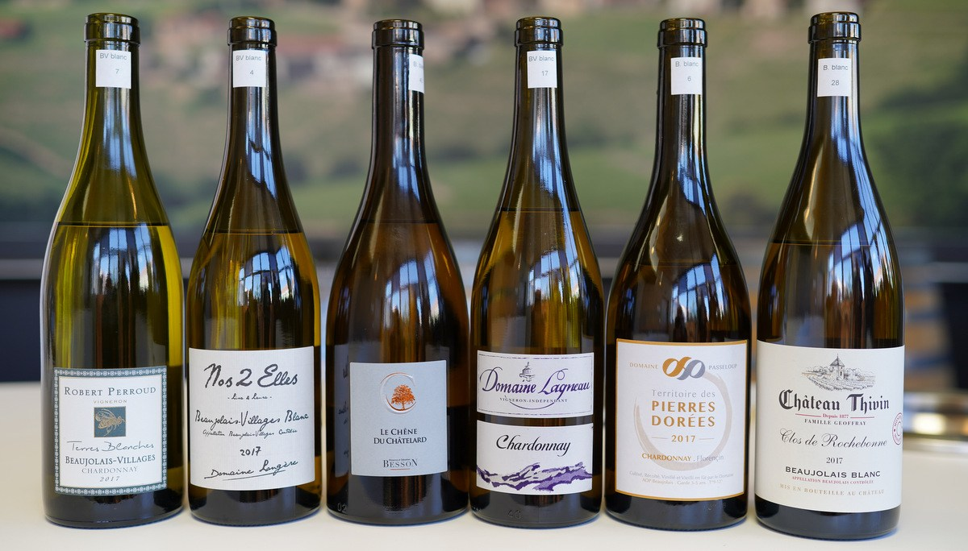
Burgundy Report by Bill Nanson

2017 Beaujolais Blanc
And the winners were…
All blind-tasted in Villefranche-sur-Saône, 22 March 2019.
The Summary:
61 wines tasted blind, though tasted in the order 1) Beaujolais Blanc and then 2) Beaujolais Villages Blanc – it was by pure chance that my picks were equally split between each AOP.
The general style of 2017 Beaujolais Blanc is more attractive than in most recent vintages – I have previously found a certain rigour to both the aromas and flavours – a mineral rigour – or you could also say a lack of charm, but in 2017 that’s rarer.
I came to this tasting, only half-jokingly, looking for ‘those 1 in 10 wines’ that I would enjoy and could recommend – as it turned out, I found that I could drink a glass or two from most of these 2017s, but I also found not just ‘good’ I found some ‘excellent’ wines – and I’m sure that you would all prefer to drink ‘excellent!’
Actually the ‘excellent‘ turned out to be 1 in 10, so look no further than this fine selection of wines, noted in the order tasted:
2017 Passeloup, Pierres Dorées Florencin, €8.90*
2017 Château Thivin – Family Geoffray, Beaujolais Clos Rochebonne, €14.50
2017 du Penlois – Besson Père & Fils, Beaujolais Le Chêne du Chatelard, €16.00
2017 Longère, Beaujolais Villages Nos 2 Elles, €9.00
2017 Robert Perroud, Beaujolais Villages Terres Blanches, €11.00
2017 Lagneau, Beaujolais Villages, price not given
*Estimate prices from the producers, ex-cellars
2017 Château Thivin – Family Geoffray, Beaujolais Clos Rochebonne
A rounded citrus nose, perhaps a touch of oak taking any sharp edges off the shape. Big and fresh in the mouth – an attack on the palate. Palate-staining flavour here – that’s impressive. Good character, great flavour. Excellent – one of the few!

